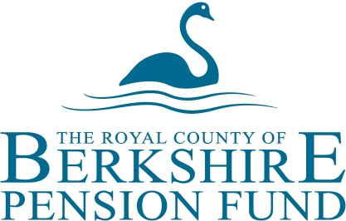

ENVIRONMENTAL, SOCIAL AND GOVERNANCE (ESG)

The Royal County of Berkshire Pension Fund (“the Fund”) is committed to responsible investment and engagement and works with its specialist Investment manager Local Pensions Partnership (Investments) Ltd (LPPI) in order to implement its portfolio. Since 2018 the Fund has been in the process of transitioning its assets into pooled investment arrangements where it is able to benefit from increased scale and resources which are enabling improved evaluation of risks and greater capacity to engage and mitigate these risks.

The Fund is committed to long-term responsible investment of pension savings. We recognise that we have a fiduciary duty to act in the best long-term interests of our members and stakeholders. To do so properly requires us to recognise that environmental, social and governance issues can positively and negatively impact on the Fund which should be considered in our investment strategies and decision-making processes. The Fund continually reviews its policies with respect to responsible investment and plans to update its policies when necessary.

In the meantime it should be noted that through LPPI the Fund is already actively engaging in managing a range of ESG risks. LPPI’s responsible investment policies can be viewed on the LPPI website, including specific reference to climate risks and measures to manage these. LPPI is a signatory to the UN PRI and works collaboratively with a range of aligned groups including Climate Action 100+ and the Transition Pathway Initiative.

Cllr. Julian Sharpe
Chairman
Royal County of Berkshire Pension Fund Panel and Advisory Panel
November 2019

